

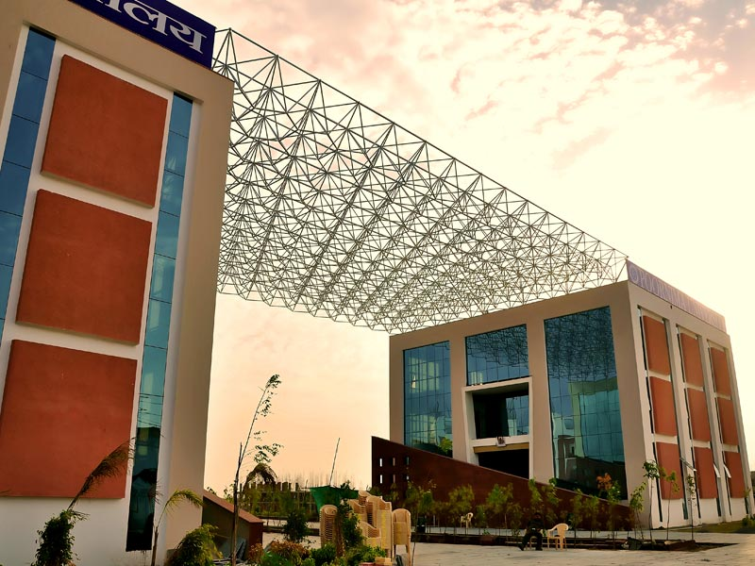

**SCHOOL OF BASIC & APPLIED SCIENCES**

**DEPARTMENT OF COMPUTER APPLICATION**

**TEACHING SCHEMES**

**Bachelor of Computer Applications**

**(Spl. IT Infrastructure Management Services & Cloud Technology)**

**(Batch 2014-17)**

|  |  |  |  |  |  |
| --- | --- | --- | --- | --- | --- |
| **POORNIMA UNIVERSITY** | | | | | |
| **BCA- ITIMS & Cloud Tech. (Batch 2014-17)** | | | | | |
| **First Year - First Semester** | | | | | |
| **Subject Code** | **Subject Name** | **Teaching Scheme (Hrs per week)** | | | **Credits** |
| **Lec (L)** | **Tut (T)** | **Prac (P)** |
| **A.** | **Core Subjects (Theory)** |  |  |  |  |
| BCT01101 | Office Automation Tools | 4 | - | - | 4 |
| BCT01102 | English I | 4 | - | - | 4 |
| BCT01103 | Fundamentals of Mathematics | 4 | - | - | 4 |
| BCT01104 | Computer Fundamentals & Organization | 4 | - | - | 4 |
| BCT01105 | Programming in C | 4 | - | - | 4 |
| BCT01106 | Introduction to Linux | 4 | - | - | 4 |
| **B.** | **Practicals** |  |  |  |  |
| BCT01207 | C Programming Lab | - | - | 4 | 2 |
| BCT01208 | Linux Lab | - | - | 2 | 1 |
| BCT01209 | Soft Skills-I | - | - | 2 | 1 |
| **C.** | **Project/Seminar** |  |  |  |  |
|  | - | - | - | - | - |
| **D.** | **Programmes / Activities** |  |  |  |  |
| BCT01610 | **Discipline and Talent Enrichment Programme (TEP) – I** |  |  |  | **2** |
| BCT01610.1 | Effective Speaking and Analytical Skills - I | 2 | - | - | - |
| BCT01610.2 | Online Eligibility Exam (OLE) | 1 | - | - | - |
| BCT01610.3 | Programming Demonstrations | 1 | - | - | - |
| BCT01610.4 | Domain-level Tutorials | 1 | - | - | - |
| BCT01610.5 | Research and Presentations | 2 | - | - | - |
|  | **Total** | **31** |  | **8** | **30** |
|  | **Total Teaching Hours** | **39** | | |
|  |  |  |  |  |  |

|  |  |  |  |  |  |
| --- | --- | --- | --- | --- | --- |
| **POORNIMA UNIVERSITY** | | | | | |
| **BCA- ITIMS & Cloud Tech. (Batch 2014-17)** | | | | | |
| **First Year - Second Semester** | | | | | |
| **Subject Code** | **Subject Name** | **Teaching Scheme (Hrs per week)** | | | **Credits** |
| **Lec (L)** | **Tut (T)** | **Prac (P)** |
| **A.** | **Core Subjects (Theory)** |  |  |  |  |
| BCT02101 | Discrete Mathematics | 4 | - | - | 4 |
| BCT02102 | English II | 4 | - | - | 4 |
| BCT02103 | Operating System | 5 | - | - | 5 |
| BCT02104 | OOPS with C++ | 4 | - | - | 4 |
| BCT02105 | Data Structures Using C | 4 | - | - | 4 |
| BCT02106 | System Configuration and Maintenance | 4 | - | - | 4 |
| **B.** | **Practicals** |  |  |  |  |
| BCT02207 | OOPS with C++ Lab | - | - | 4 | 2 |
| BCT02208 | Data Structures Lab | - | - | 4 | 2 |
| BCT02209 | Life and Career Skills | - | - | 2 | 1 |
| **C.** | **Project/Seminar** |  |  |  |  |
|  | - | - | - | - | - |
| **D.** | **Programmes / Activities** |  |  |  |  |
| BCT02610 | **Discipline and Talent Enrichment Programme (TEP) - II** |  |  |  | **2** |
| BCT02610.1 | Online Eligibility Exam (OLE) | 1 | - | - | - |
| BCT02610.2 | Programming Demonstrations | 1 | - | - | - |
| BCT02610.3 | Domain-level Tutorials | 1 | - | - | - |
| BCT02610.4 | Effective Speaking and Analytical Skills - II | 1 | - | - | - |
|  | **Total** | **29** |  | **10** | **32** |
|  | **Total Teaching Hours** | **39** | | |
|  |  |  |  |  |  |

|  |  |  |  |  |  |
| --- | --- | --- | --- | --- | --- |
| **POORNIMA UNIVERSITY** | | | | | |
| **BCA- ITIMS & Cloud Tech. (Batch 2014-17)** | | | | | |
| **Second Year - Third Semester** | | | | | |
| **Subject Code** | **Subject Name** | **Teaching Scheme (Hrs per week)** | | | **Credits** |
| **Lec (L)** | **Tut (T)** | **Prac (P)** |
| **A.** | **Core Subjects (Theory)** |  |  |  |  |
| BCT03101 | Introduction to RDBMS | 5 | - | - | 5 |
| BCT03102 | Object Oriented Programming with Java | 4 | - | - | 4 |
| BCT03103 | Server Operating System - I | 4 | - | -- | 4 |
| BCT03104 | Computer Networks | 5 | - | - | 5 |
| **B.** | **Departmental Elective (Theory) : ANY ONE** | | | | |
| BCT03105 | Information Security Fundamentals | 4 | - | - | 4 |
| BCT03106 | Cryptography Fundamentals |
| **C.** | **Practicals** |  |  |  |  |
| BCT03207 | RDBMS Lab | - | - | 4 | 2 |
| BCT03208 | Object Oriented Programming with Java Lab | - | - | 4 | 2 |
| BCT03209 | Soft Skills-II | - | - | 2 | 1 |
| **D.** | **Project/Seminar** |  |  |  |  |
| BCT03410 | Technical Seminar |  |  | 2 | 1 |
| **E.** | **Programmes / Activities** |  |  |  |  |
| **BCT03611** | **Discipline and Talent Enrichment Programme (TEP) - III** |  |  |  | **2** |
| **BCT03611.1** | Online Eligibility Exam (OLE) | 1 | - | - | - |
| **BCT03611.2** | Programming Demonstrations | 1 | - | - | - |
| **BCT03611.3** | Personal Effectiveness | 2 | - | - | - |
| **BCT03611.4** | Research and Presentations | 1 | - | - | - |
|  | **Total** | **27** |  | **12** | **30** |
|  | **Total Teaching Hours** | **39** | | |
|  |  |  |  |  |  |
|  |  |  |  |  |  |
| **POORNIMA UNIVERSITY** | | | | | |
| **BCA- ITIMS & Cloud Tech. (Batch 2014-17)** | | | | | |
| **Second Year - Fourth Semester** | | | | | |
| **Subject Code** | **Subject Name** | **Teaching Scheme (Hrs per week)** | | | **Credits** |
| **Lec** | **Tut** | **Prac** |
| **A.** | **Core Subjects (Theory)** |  |  |  |  |
| BCT04101 | Ethical Hacking Fundamentals | 4 | - | - | 4 |
| BCT04102 | Introduction to Web Technology | 4 | - | - | 4 |
| BCT04103 | Fundamentals of Datacenter | 5 | - | - | 5 |
| BCT04104 | Introduction to Cloud Technology | 4 | - | - | 4 |
| **B.** | **Departmental Elective (Theory) : ANY ONE** |  |  |  |  |
| BCT04105 | Server Network Infrastructure | 3 | - | - | 3 |
| BCT04106 | Routing and Switching Administration |
| **C.** | **Practicals** |  |  |  |  |
| BCT04207 | Introduction to Web Technology Lab | - | - | 4 | 2 |
| BCT04208 | Ethical Hacking Fundamentals Lab | - | - | 4 | 2 |
| BCT04209 | Soft Skills-III | - | - | 2 | 1 |
| **D.** | **Projects/Seminar** |  |  |  |  |
| BCT04310 | Mini Project | - | - | 2 | 1 |
| **E.** | **Programmes / Activities** |  |  |  |  |
| **BCT04611** | **Discipline and Talent Enrichment Programme (TEP) - IV** |  |  |  | **2** |
| **BCT04611.1** | Online Eligibility Exam (OLE) | 1 | - | - | - |
| **BCT04611.2** | Transformational Skills/Campus Recruitment Training | 2 | - | - | - |
| **BCT04611.3** | Programming Demonstrations | 1 | - | - | - |
| **BCT04611.4** | Extra Curricular Activities - Events | 1 | - | - | - |
|  | **Total** | **25** |  | **12** | **28** |
|  | **Total Teaching Hours** | **37** | | |
| **Professional Certificate Course (PCC)** shall be offered to all students equivalent to **2 hrs/wk.** This course is Non credit Certificate course and therefore is not a part of mark sheet / grade sheet. **Students** shall be required to go for summer training for **1 month** and this training will be evaluated in next semester as **ITS** | | | | | |
|  |  |  |  |  |  |
| **POORNIMA UNIVERSITY** | | | | | |
| **BCA- ITIMS & Cloud Tech. (Batch 2014-17)** | | | | | |
| **Third Year - Fifth Semester** | | | | | |
| **Subject Code** | **Subject Name** | **Teaching Scheme (Hrs per week)** | | | **Credits** |
| **Lec** | **Tut** | **Prac** |
| **A.** | **Core Subjects (Theory)** |  |  |  |  |
| BCT05101 | Server Operating System - II | 5 | - | - | 5 |
| BCT05102 | Principles of Virtualization | 4 | - | - | 4 |
| BCT05103 | Introduction to Cloud Computing Solutions | 4 | - | - | 4 |
| BCT05104 | Private Cloud Architecture | 4 | - | - | 4 |
| **B.** | **Departmental Elective (Theory) : ANY ONE** | | | | |
| BCT05105 | Fundamentals of IT Infrastructure Library | 4 | - | - | 4 |
| BCT05106 | Virtualization & Cloud Security |
| **C.** | **Practicals** |  |  |  |  |
| BCT05207 | Server Operating System Lab- II | - | - | 4 | 2 |
| BCT05208 | Introduction to Cloud Computing Solutions Lab | - | - | 4 | 2 |
| **D.** | **Project/Seminar** |  |  |  |  |
| BCT05309 | Industrial Training Seminar (ITS) | - | - | 2 | 1 |
| **E.** | **Programmes / Activities** |  |  |  |  |
| BCT05610 | **Discipline and Talent Enrichment Programme (TEP) - V** |  |  |  | **2** |
| BCT05610.1 | Online Eligibility Exam (OLE) | 1 | - | - | - |
| BCT05610.2 | Transition from Campus to Corporate/Aptitude/ Campus Recruitment Training | 3 | - | - | - |
| BCT05610.3 | Programming Demonstrations | 1 | - | - | - |
| BCT05610.4 | Extra Curricular Activities - Events | 1 | - | - | - |
|  | **Total** | **27** |  | **10** | **28** |
|  | **Total Teaching Hours** | **37** | | |
| **Professional Certificate Course (PCC)** shall be offered to all students equivalent to **2 hrs/wk.** This course is Non credit Certificate course and therefore is not a part of mark sheet / grade sheet. | | | | | |
|  |  |  |  |  |  |
| **POORNIMA UNIVERSITY** | | | | | |
| **BCA- ITIMS & Cloud Tech. (Batch 2014-17)** | | | | | |
| **Third Year - Sixth Semester** | | | | | |
| **Subject Code** | **Subject Name** | **Teaching Scheme (Hrs per week)** | | | **Credits** |
| **Lec** | **Tut** | **Prac** |
| **A.** | **Core Subjects (Theory)** |  |  |  |  |
| BCT06101 | Mobile, Wireless and VOIP Security | 4 | - | - | 4 |
| BCT06102 | Amazon Web Services (AWS) | 4 | - | - | 4 |
| **B.** | **Departmental Elective (Theory) : ANY ONE** | | | | |
| BCT06103 | Business Organization Basics | 4 | - | - | 4 |
| BCT06104 | Professional Development Skills |
| **C.** | **Practicals** |  |  |  |  |
| BCT06205 | Mobile, Wireless and VOIP Security Lab | - | - | 4 | 2 |
| BCT06206 | AWS Lab | - | - | 4 | 2 |
|  |  |  |  |  |  |
| **D.** | **Project/Seminar** |  |  |  |  |
| BCT06307 | Major Project | - | - | 12 | 6 |
| **E.** | **Programmes / Activities** |  |  |  |  |
| BCT06608 | **Discipline and Talent Enrichment Programme (TEP) - VI** |  |  |  | **2** |
| BCT06608.1 | Online Eligibility Exam (OLE) | 1 | - | - | - |
| BCT06608.2 | Aptitude/ Campus Recruitment Training | 2 | - | - | - |
|  | **Total** | **15** |  | **20** | **24** |
|  | **Total Teaching Hours** | **35** | | |
| **Professional Certificate Course (PCC)** shall be offered to all students equivalent to **4** **hrs/wk.** This course is Non credit Certificate course and therefore is not a part of mark sheet / grade sheet. | | | | | |

**\*\*\*\*\***